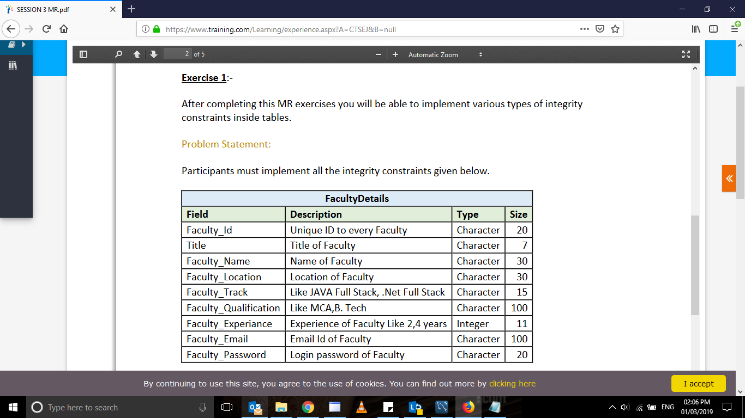

alter TABLE facultydetail

ADD UNIQUE(faculty_id) ;

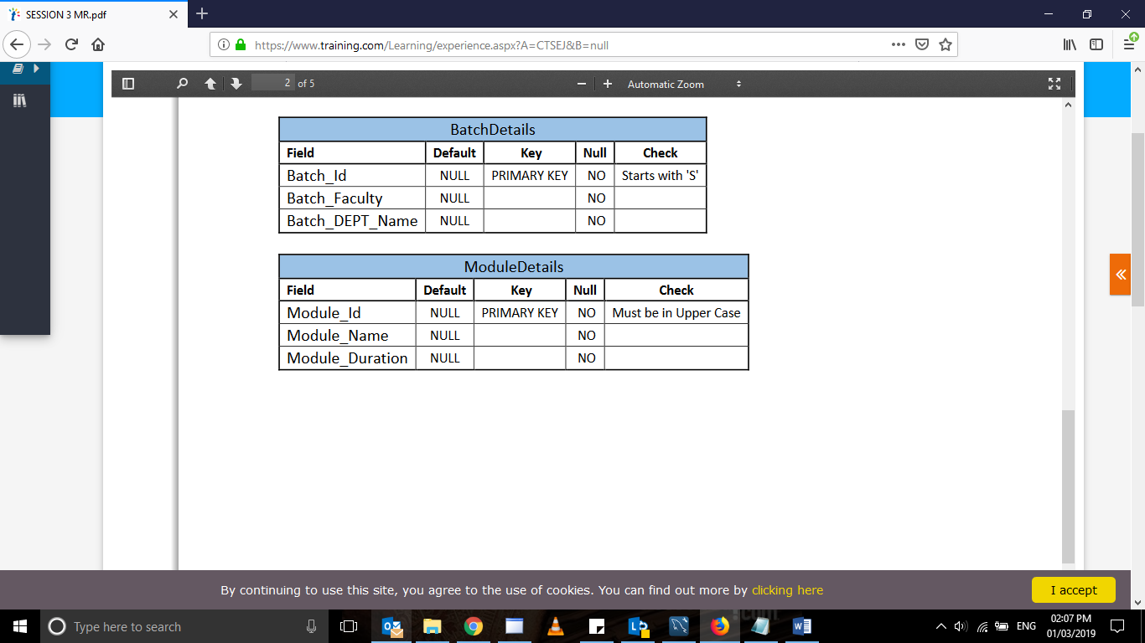

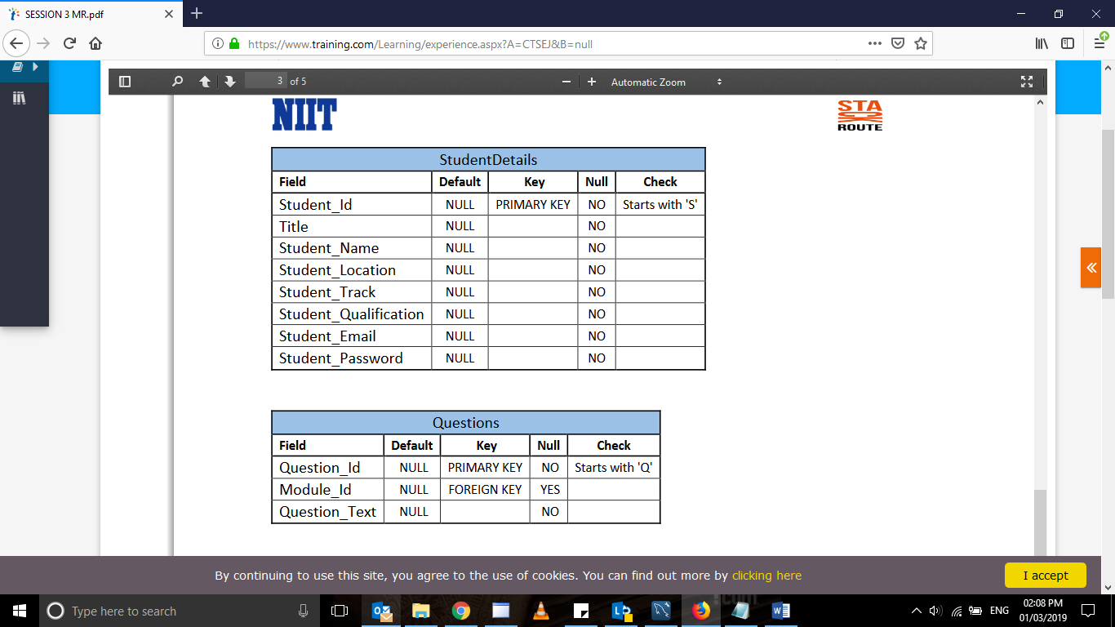

alter TABLE studentdetail

ADD primary key(student_id) ;

alter TABLE questions

ADD primary key(question_id) ;

ALTER TABLE questions

add FOREIGN KEY (Module_ID) REFERENCES Moduledetails(module_ID);

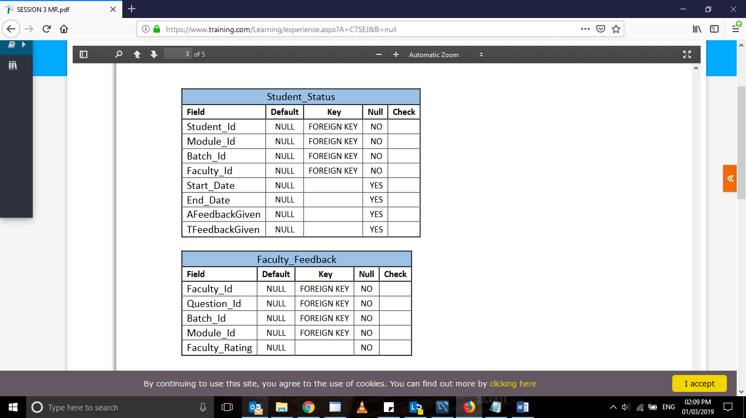

ALTER TABLE student_status

add FOREIGN KEY (student_ID) REFERENCES studentdetail(student_ID);

ALTER TABLE student_status

add FOREIGN KEY (module_ID) REFERENCES studentdetail(module_ID);

ALTER TABLE student_status

add FOREIGN KEY (batch_ID) REFERENCES studentdetail(batch_ID);

ALTER TABLE student_status

add FOREIGN KEY (faculty_ID) REFERENCES studentdetail(faculty_ID);

ALTER TABLE faculty_feedback

add FOREIGN KEY (faculty_ID) REFERENCES questions(faculty_ID);

ALTER TABLE faculty_feedback

add FOREIGN KEY (question_ID) REFERENCES questions(question_ID);

ALTER TABLE faculty_feedback

add FOREIGN KEY (batch_ID) REFERENCES questions(batch_ID);

ALTER TABLE faculty_feedback

add FOREIGN KEY (module_ID) REFERENCES questions(module_ID);

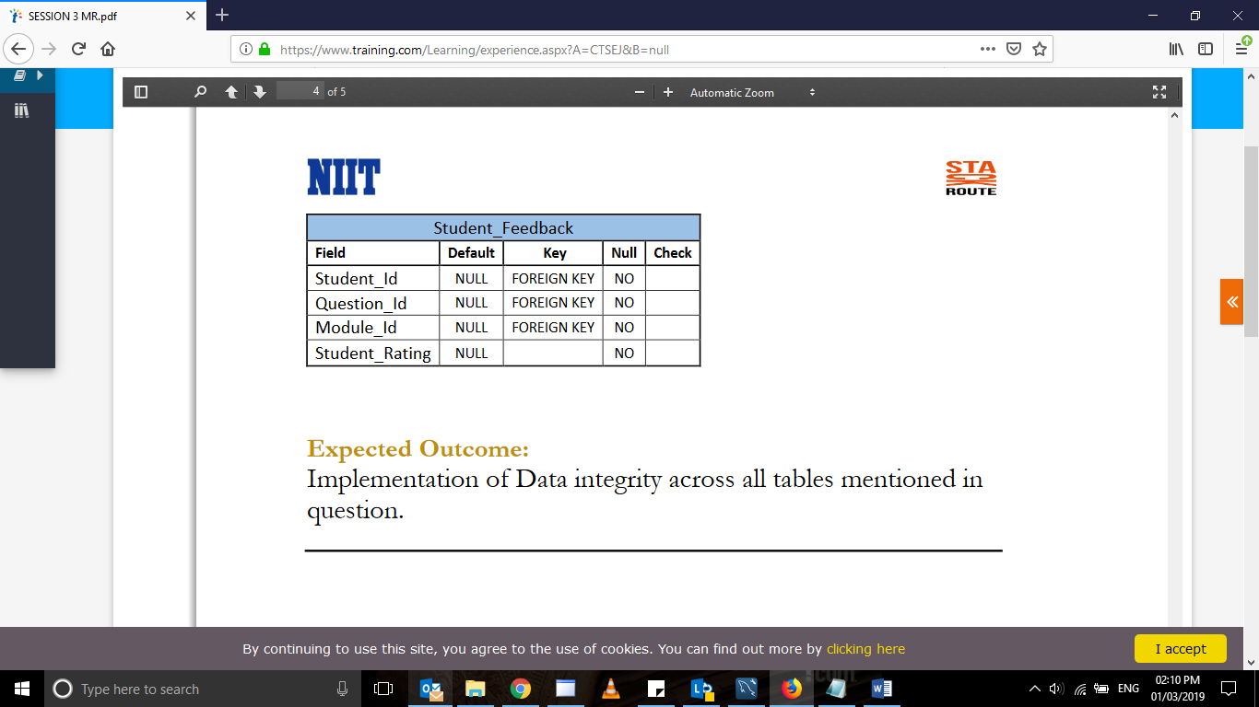

ALTER TABLE student_feedback

add FOREIGN KEY (student_ID) REFERENCES studentdetail(student_ID);

ALTER TABLE student_feedback

add FOREIGN KEY (question_ID) REFERENCES studentdetail(question_ID);

ALTER TABLE student_feedback

add FOREIGN KEY (module_ID) REFERENCES studentdetail(question_ID);

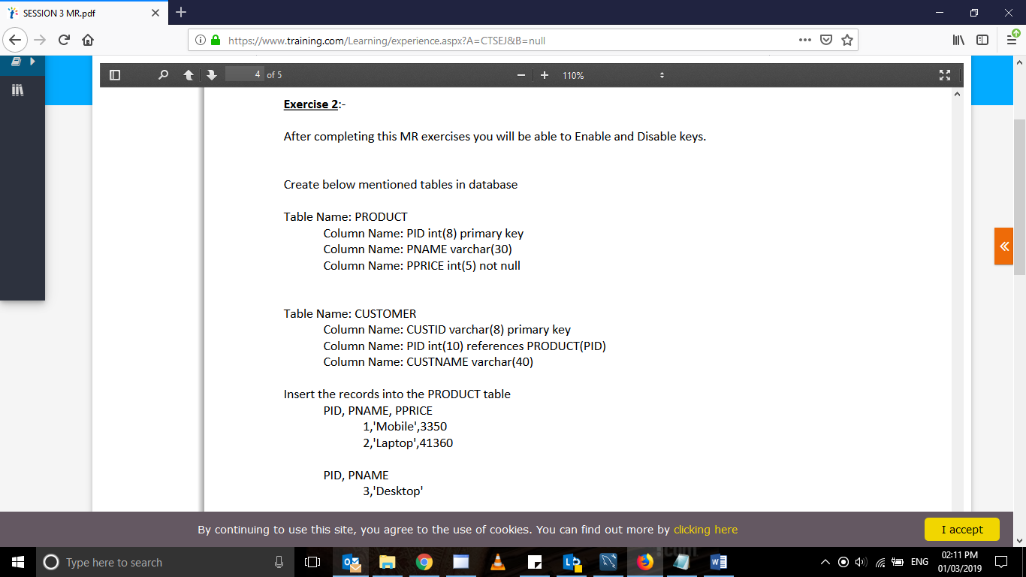

create table product( PID int(8) primary key ,

PName varchar(30) , PPrice int(5) not null );

create table customer

( custid varchar(8) primary key,

PID int(10) references product(PID),

Custname varchar(40));

insert into product values

(1,'Mobile',3350);

insert into product values

(2,'Mobile',41360);

insert into product values

(3,'Desktop',null);

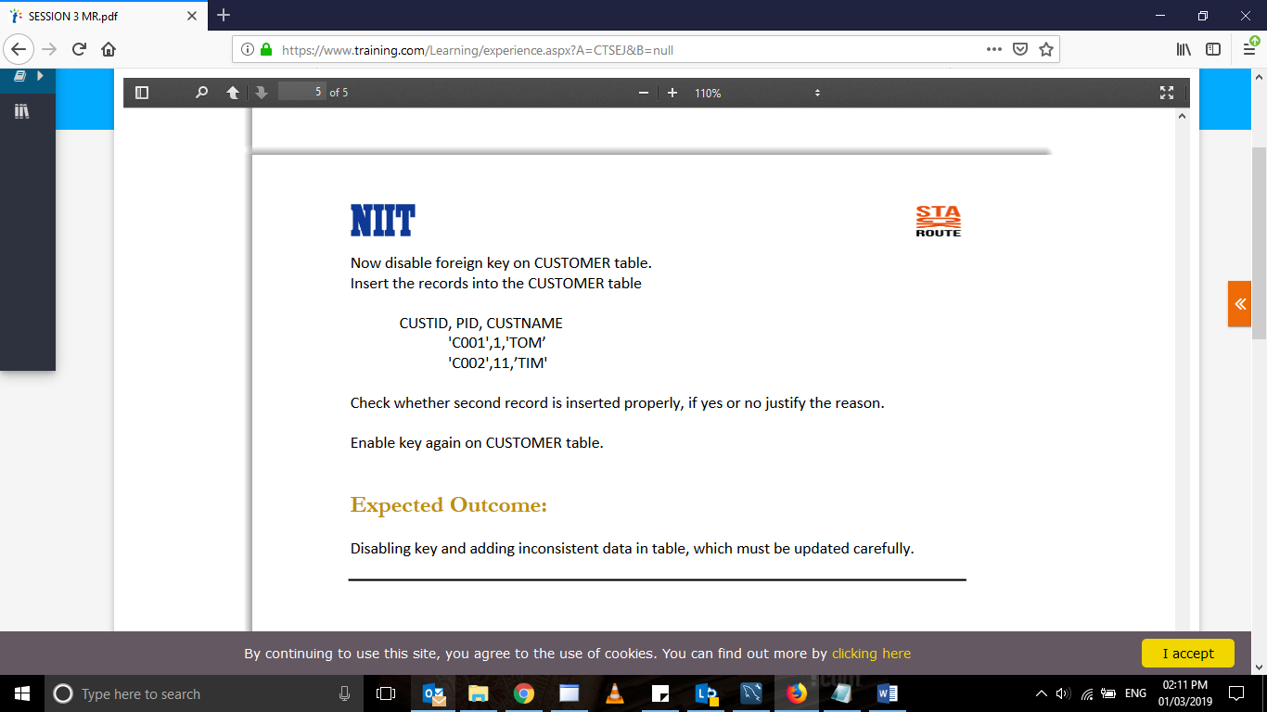

in